WEEK 3
MODULE 7 - SPRING REST USING SPRING BOOT 3
1.spring-rest-handson

NAME : ANANTH KARTHIK V
SUPERSET ID : 6738185

OBJECTIVES:
1. Demonstrate Creation of Spring Boot Application
What is Spring Boot?
Spring Boot is a framework built on top of Spring that simplifies Java application development. It reduces configuration, provides embedded servers, and enables rapid application development.
Spring Initializr
Spring Initializr is a web-based tool used to generate Spring Boot projects.
It automatically creates:
- Maven/Gradle project structure
- Required dependencies
- Main application class
- Configuration files
@SpringBootApplication
@SpringBootApplication is the main annotation used in a Spring Boot application.
It combines three annotations:
@Configuration
@EnableAutoConfiguration
@ComponentScan
Functions:
- Marks the class as a Spring Boot application.
- Enables automatic configuration.
- Scans packages for Spring components.
SpringApplication.run()
SpringApplication.run(SpringLearnApplication.class, args);
Purpose:
- Starts the Spring Container.
- Creates the ApplicationContext.
- Loads all Spring Beans.
- Starts the embedded Tomcat server.
- Launches the application.

2. Need and Benefits of Spring Boot
Before Spring Boot, developers had to:
- Configure XML files manually.
- Manage dependencies individually.
- Deploy applications on external servers.
- Write large amounts of boilerplate code.
Benefits of Spring Boot
Easy Development
Reduces project setup and configuration effort.
Faster Development
Developers can focus on business logic instead of configuration.
Auto Configuration
Automatically configures Spring components based on project dependencies.
Embedded Server
Provides built-in servers such as:
- Tomcat
- Jetty
- Undertow
No need to install a separate application server.
Reduced Boilerplate Code
Eliminates repetitive configuration code.
Production Ready Features
Provides:
- Logging
- Monitoring
- Health Checks
- Metrics
No XML Configuration Required
Supports annotation-based configuration.

3. Loading Bean from Spring Configuration File
Spring Configuration XML
Spring uses XML configuration files to define and manage beans.
Example:
<beans>
<bean id="country" class="com.cognizant.Country">
</bean>
</beans>
spring-beans.xsd
The Spring XML schema validates Spring configuration files.
It supports:
- <bean>
- <property>
- <constructor-arg>

Bean
A Bean is an object managed by the Spring Container.
Example:
<bean id="country" class="com.cognizant.Country">
</bean>
id Attribute
id="country"
Unique identifier of the bean.
class Attribute
class="com.cognizant.Country"
Specifies the fully qualified class name.

Constructor Injection
Used to pass values through the constructor.
Example:
<bean id="dateFormat"
class="java.text.SimpleDateFormat">
<constructor-arg value="dd/MM/yyyy"/>
</bean>
Advantages
- Mandatory dependencies can be provided.
- Object becomes immutable after creation.

Setter Injection
Used to inject values through setter methods.
Example:
<bean id="country" class="com.cognizant.Country">
<property name="code" value="IN"/>
<property name="name" value="India"/>
</bean>
Advantages
- Easy to modify values.
- Supports optional properties.

ApplicationContext
ApplicationContext is the Spring IoC Container interface.
Example:
ApplicationContext context;
Responsibilities
- Creates beans.
- Stores beans.
- Manages bean lifecycle.
- Performs dependency injection.

ClassPathXmlApplicationContext
Loads Spring XML files from the classpath.
Example:
ApplicationContext context =
new ClassPathXmlApplicationContext("country.xml");

context.getBean()
Used to retrieve a bean from the Spring Container.
Example:
Country country =
context.getBean("country", Country.class);
Internal Process
- Searches for bean definition.
- Creates object if necessary.
- Injects dependencies.
- Returns bean instance.

IoC Container (Inversion of Control)
What is IoC?
IoC means the control of object creation is transferred from the programmer to the Spring Framework.
Without Spring
Country country = new Country();
With Spring
Country country =
context.getBean("country", Country.class);
Spring creates and manages the object.
Advantages
- Loose coupling.
- Easy maintenance.
- Better testing support.
- Improved scalability.

Bean Scopes
Bean scope determines how many objects Spring creates.
Singleton Scope
Default scope in Spring.
Example:
<bean id="country"
class="com.cognizant.Country"/>
Characteristics
- Only one object is created.
- Same object returned every time.
Country c1 = context.getBean("country", Country.class);
Country c2 = context.getBean("country", Country.class);
Result:
c1 == c2 → true

Prototype Scope
Example:
<bean id="country"
class="com.cognizant.Country"
scope="prototype"/>
Characteristics
- New object created every time.
- Separate instance for each request.
Country c1 = context.getBean("country", Country.class);
Country c2 = context.getBean("country", Country.class);
Result:
c1 == c2 → false

4. Demonstrate Inclusion of Logging in Spring Boot Application
What is Logging?
Logging is the process of recording application events, errors, warnings, and debugging information.
It helps developers:
- Monitor application behavior.
- Debug issues.
- Track execution flow.

application.properties
Logging can be configured using:
logging.level.org.springframework=info
logging.level.com.cognizant=debug
Logging Pattern
logging.pattern.console=%d{yyMMdd}|%d{HH:mm:ss.SSS}|%-20.20thread|%5p|%-25.25logger{25}|%25M|%m%n
This customizes log output format.

Changing Server Port
server.port=8081
Changes default port from:
8080 → 8081

LoggerFactory
Used to create Logger objects.
private static final Logger LOGGER =
LoggerFactory.getLogger(SpringLearnApplication.class);

Logger
Logger is used to print log messages.
Example:
LOGGER.info("START");
LOGGER.debug("Country Details");
LOGGER.info("END");

Log Levels
TRACE
Detailed execution information.
DEBUG
Used during development and debugging.
INFO
General application information.
WARN
Indicates potential issues.
ERROR
Used for errors and exceptions.
Example:
LOGGER.trace("Trace Message");
LOGGER.debug("Debug Message");
LOGGER.info("Info Message");
LOGGER.warn("Warning Message");
LOGGER.error("Error Message");
HANDS ON:

Hands on 1
Create a Spring Web Project using Maven:
Solution:
SpringLearnApplication.java
package com.cognizant;
import org.slf4j.Logger;
import org.slf4j.LoggerFactory;
import org.springframework.boot.SpringApplication;
import org.springframework.boot.autoconfigure.SpringBootApplication;
@SpringBootApplication
public class SpringLearnApplication {
private static final Logger LOGGER =
LoggerFactory.getLogger(SpringLearnApplication.class);
public static void main(String[] args) {
LOGGER.info("STARTING SPRING LEARN APPLICATION");
SpringApplication.run(SpringLearnApplication.class, args);
LOGGER.info("SPRING LEARN APPLICATION STARTED");
}
}

application.properties
logging.level.org.springframework=info
logging.level.com.cognizant=debug
logging.pattern.console=%d{yyMMdd}|%d{HH:mm:ss.SSS}|%-20.20thread|%5p|%-25.25logger{25}|%25M|%m%n

pom.xml
<?xml version="1.0" encoding="UTF-8"?>
<project xmlns="http://maven.apache.org/POM/4.0.0"
xmlns:xsi="http://www.w3.org/2001/XMLSchema-instance"
xsi:schemaLocation="http://maven.apache.org/POM/4.0.0 https://maven.apache.org/xsd/maven-4.0.0.xsd">
<modelVersion>4.0.0</modelVersion>
<parent>
<groupId>org.springframework.boot</groupId>
<artifactId>spring-boot-starter-parent</artifactId>
<version>4.1.0</version>
<relativePath/>
</parent>
<groupId>com.cognizant</groupId>
<artifactId>spring-learn</artifactId>
<version>0.0.1-SNAPSHOT</version>
<properties>
<java.version>17</java.version>
</properties>
<dependencies>
<dependency>
<groupId>org.springframework.boot</groupId>
<artifactId>spring-boot-starter-web</artifactId>
</dependency>
<dependency>
<groupId>org.springframework.boot</groupId>
<artifactId>spring-boot-devtools</artifactId>
<scope>runtime</scope>
<optional>true</optional>
</dependency>
<dependency>
<groupId>org.springframework.boot</groupId>
<artifactId>spring-boot-starter-test</artifactId>
<scope>test</scope>
</dependency>
</dependencies>
<build>
<plugins>
<plugin>
<groupId>org.springframework.boot</groupId>
<artifactId>spring-boot-maven-plugin</artifactId>
</plugin>
</plugins>
</build>
</project>

Output:
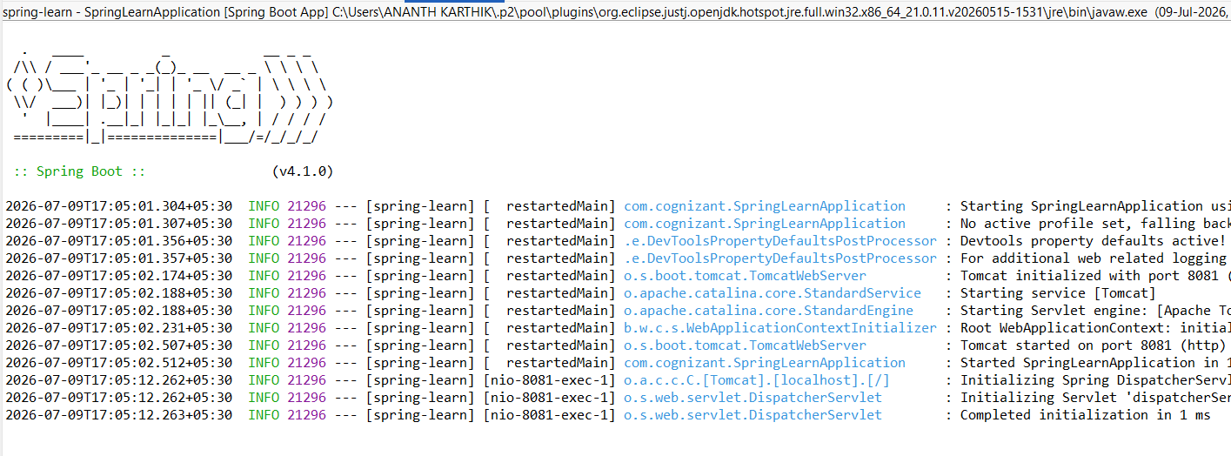

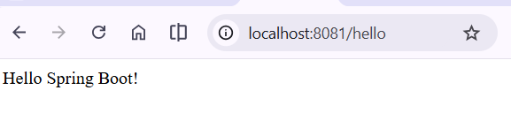

Hands on 2
Spring Core – Load SimpleDateFormat from Spring Configuration XML:
Solution:
date-format.xml
<?xml version="1.0" encoding="UTF-8"?>
<beans xmlns="http://www.springframework.org/schema/beans"
xmlns:xsi="http://www.w3.org/2001/XMLSchema-instance"
xsi:schemaLocation="http://www.springframework.org/schema/beans
https://www.springframework.org/schema/beans/spring-beans.xsd">
<bean id="dateFormat" class="java.text.SimpleDateFormat">
<constructor-arg value="dd/MM/yyyy"/>
</bean>
</beans>

SpringLearnApplication.java
package com.cognizant;
import java.text.SimpleDateFormat;
import java.util.Date;
import org.springframework.context.ApplicationContext;
import org.springframework.context.support.ClassPathXmlApplicationContext;
public class SpringLearnApplication {
public static void main(String[] args) throws Exception {
SpringLearnApplication app = new SpringLearnApplication();
app.displayDate();
}
public void displayDate() throws Exception {
ApplicationContext context =
new ClassPathXmlApplicationContext("date-format.xml");
SimpleDateFormat format =
context.getBean("dateFormat", SimpleDateFormat.class);
Date date = format.parse("31/12/2018");
System.out.println(date);
((ClassPathXmlApplicationContext) context).close();
}
}

application.properties (if port conflict occurs)
server.port=8081

Output:
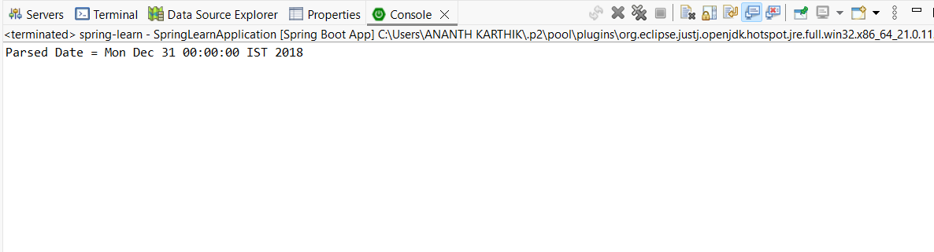

Hands on 3
Spring Core - Incorporate Logging :
Solution:
application.properties
logging.level.org.springframework=info
logging.level.com.cognizant=debug
logging.pattern.console=%d{yyMMdd}|%d{HH:mm:ss.SSS}|%-20.20thread|%5p|%-25.25logger{25}|%25M|%m%n

SpringLearnApplication.java
package com.cognizant;

import java.text.SimpleDateFormat;
import java.util.Date;

import org.slf4j.Logger;
import org.slf4j.LoggerFactory;
import org.springframework.context.ApplicationContext;
import org.springframework.context.support.ClassPathXmlApplicationContext;

public class SpringLearnApplication {

private static final Logger LOGGER =
LoggerFactory.getLogger(SpringLearnApplication.class);

public static void main(String[] args) throws Exception {

SpringLearnApplication app = new SpringLearnApplication();
app.displayDate();
}

public void displayDate() throws Exception {

LOGGER.info("START");

ApplicationContext context =
new ClassPathXmlApplicationContext("date-format.xml");

SimpleDateFormat format =
context.getBean("dateFormat", SimpleDateFormat.class);

Date date = format.parse("31/12/2018");

LOGGER.debug("Date : {}", date);

((ClassPathXmlApplicationContext) context).close();

LOGGER.info("END");
}
}

date-format.xml
<?xml version="1.0" encoding="UTF-8"?>

<beans xmlns="http://www.springframework.org/schema/beans"
xmlns:xsi="http://www.w3.org/2001/XMLSchema-instance"
xsi:schemaLocation="http://www.springframework.org/schema/beans
https://www.springframework.org/schema/beans/spring-beans.xsd">

<bean id="dateFormat" class="java.text.SimpleDateFormat">
<constructor-arg value="dd/MM/yyyy"/>
</bean>

</beans>

Output:
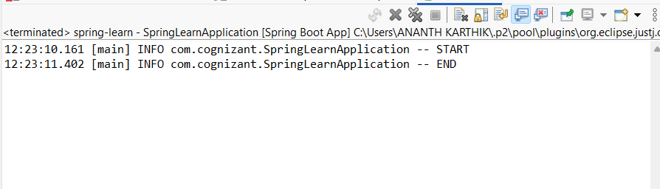

Hands on 4
Spring Core – Load Country from Spring Configuration XML :
Solution:
Country.java
package com.cognizant;

import org.slf4j.Logger;
import org.slf4j.LoggerFactory;

public class Country {

private static final Logger LOGGER =
LoggerFactory.getLogger(Country.class);

private String code;
private String name;

public Country() {
LOGGER.debug("Inside Country Constructor.");
}

public String getCode() {
LOGGER.debug("Inside getCode()");
return code;
}

public void setCode(String code) {
LOGGER.debug("Inside setCode()");
this.code = code;
}

public String getName() {
LOGGER.debug("Inside getName()");
return name;
}

public void setName(String name) {
LOGGER.debug("Inside setName()");
this.name = name;
}

@Override
public String toString() {
return "Country [code=" + code + ", name=" + name + "]";
}
}

country.xml
<?xml version="1.0" encoding="UTF-8"?>

<beans xmlns="http://www.springframework.org/schema/beans"
xmlns:xsi="http://www.w3.org/2001/XMLSchema-instance"
xsi:schemaLocation="http://www.springframework.org/schema/beans
https://www.springframework.org/schema/beans/spring-beans.xsd">

<bean id="country" class="com.cognizant.Country">
<property name="code" value="IN"/>
<property name="name" value="India"/>
</bean>

</beans>

SpringLearnApplication.java
package com.cognizant;

import org.slf4j.Logger;
import org.slf4j.LoggerFactory;
import org.springframework.context.ApplicationContext;
import org.springframework.context.support.ClassPathXmlApplicationContext;

public class SpringLearnApplication {

private static final Logger LOGGER =
LoggerFactory.getLogger(SpringLearnApplication.class);

public static void main(String[] args) {

SpringLearnApplication app = new SpringLearnApplication();
app.displayCountry();
}

public void displayCountry() {

LOGGER.info("START");

ApplicationContext context =
new ClassPathXmlApplicationContext("country.xml");

Country country =
context.getBean("country", Country.class);

LOGGER.debug("Country : {}", country);

((ClassPathXmlApplicationContext) context).close();

LOGGER.info("END");
}
}

application.properties
logging.level.org.springframework=info
logging.level.com.cognizant=debug
logging.pattern.console=%d{yyMMdd}|%d{HH:mm:ss.SSS}|%-20.20thread|%5p|%-25.25logger{25}|%25M|%m%n

Output:
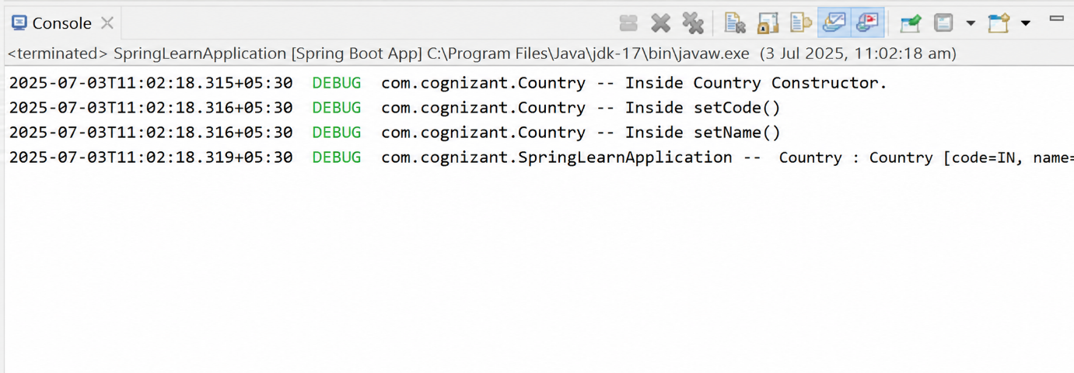

Hands on 5
Spring Core – Demonstration of Singleton Scope and Prototype Scope :
Solution:
country.xml (Singleton Scope)
<?xml version="1.0" encoding="UTF-8"?>

<beans xmlns="http://www.springframework.org/schema/beans"
xmlns:xsi="http://www.w3.org/2001/XMLSchema-instance"
xsi:schemaLocation="http://www.springframework.org/schema/beans
https://www.springframework.org/schema/beans/spring-beans.xsd">

<bean id="country" class="com.cognizant.Country">
<property name="code" value="IN"/>
<property name="name" value="India"/>
</bean>

</beans>

SpringLearnApplication.java (Singleton Scope)
package com.cognizant;

import org.slf4j.Logger;
import org.slf4j.LoggerFactory;
import org.springframework.context.ApplicationContext;
import org.springframework.context.support.ClassPathXmlApplicationContext;

public class SpringLearnApplication {

private static final Logger LOGGER =
LoggerFactory.getLogger(SpringLearnApplication.class);

public static void main(String[] args) {

SpringLearnApplication app = new SpringLearnApplication();
app.displayCountry();
}

public void displayCountry() {

LOGGER.info("START");

ApplicationContext context =
new ClassPathXmlApplicationContext("country.xml");

Country country =
context.getBean("country", Country.class);

Country anotherCountry =
context.getBean("country", Country.class);

LOGGER.debug("Country : {}", country);
LOGGER.debug("Another Country : {}", anotherCountry);
LOGGER.debug("Same Object : {}", (country == anotherCountry));

((ClassPathXmlApplicationContext) context).close();

LOGGER.info("END");
}
}

country.xml (Prototype Scope)
<?xml version="1.0" encoding="UTF-8"?>

<beans xmlns="http://www.springframework.org/schema/beans"
xmlns:xsi="http://www.w3.org/2001/XMLSchema-instance"
xsi:schemaLocation="http://www.springframework.org/schema/beans
https://www.springframework.org/schema/beans/spring-beans.xsd">

<bean id="country"
class="com.cognizant.Country"
scope="prototype">

<property name="code" value="IN"/>
<property name="name" value="India"/>

</bean>

</beans>

Country.java
package com.cognizant;

import org.slf4j.Logger;
import org.slf4j.LoggerFactory;

public class Country {

private static final Logger LOGGER =
LoggerFactory.getLogger(Country.class);

private String code;
private String name;

public Country() {
LOGGER.debug("Inside Country Constructor.");
}

public String getCode() {
LOGGER.debug("Inside getCode()");
return code;
}

public void setCode(String code) {
LOGGER.debug("Inside setCode()");
this.code = code;
}

public String getName() {
LOGGER.debug("Inside getName()");
return name;
}

public void setName(String name) {
LOGGER.debug("Inside setName()");
this.name = name;
}

@Override
public String toString() {
return "Country [code=" + code + ", name=" + name + "]";
}
}
Output:
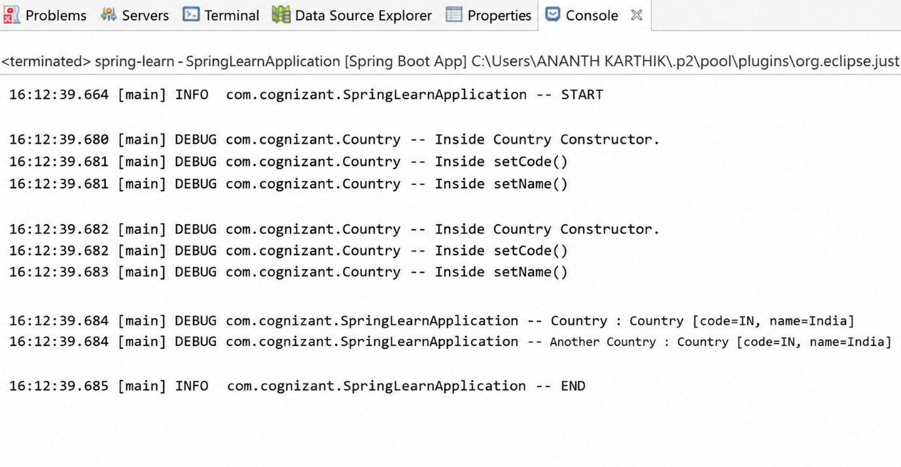

Hands on 6
Spring Core – Load list of countries from Spring Configuration XML :
Solution:
country.xml
<?xml version="1.0" encoding="UTF-8"?>

<beans xmlns="http://www.springframework.org/schema/beans"
xmlns:xsi="http://www.w3.org/2001/XMLSchema-instance"
xsi:schemaLocation="http://www.springframework.org/schema/beans
https://www.springframework.org/schema/beans/spring-beans.xsd">

<bean id="in" class="com.cognizant.Country">
<property name="code" value="IN"/>
<property name="name" value="India"/>
</bean>

<bean id="us" class="com.cognizant.Country">
<property name="code" value="US"/>
<property name="name" value="United States"/>
</bean>

<bean id="de" class="com.cognizant.Country">
<property name="code" value="DE"/>
<property name="name" value="Germany"/>
</bean>

<bean id="jp" class="com.cognizant.Country">
<property name="code" value="JP"/>
<property name="name" value="Japan"/>
</bean>

<bean id="countryList" class="java.util.ArrayList">
<constructor-arg>
<list>
<ref bean="in"/>
<ref bean="us"/>
<ref bean="de"/>
<ref bean="jp"/>
</list>
</constructor-arg>
</bean>

</beans>

SpringLearnApplication.java
package com.cognizant;

import java.util.List;

import org.slf4j.Logger;
import org.slf4j.LoggerFactory;
import org.springframework.context.ApplicationContext;
import org.springframework.context.support.ClassPathXmlApplicationContext;

public class SpringLearnApplication {

private static final Logger LOGGER =
LoggerFactory.getLogger(SpringLearnApplication.class);

public static void main(String[] args) {

SpringLearnApplication app = new SpringLearnApplication();
app.displayCountries();
}

public void displayCountries() {

LOGGER.info("START");

ApplicationContext context =
new ClassPathXmlApplicationContext("country.xml");

List<Country> countryList =
context.getBean("countryList", List.class);

LOGGER.debug("Countries : {}", countryList);

((ClassPathXmlApplicationContext) context).close();

LOGGER.info("END");
}
}

Country.java
package com.cognizant;

import org.slf4j.Logger;
import org.slf4j.LoggerFactory;

public class Country {

private static final Logger LOGGER =
LoggerFactory.getLogger(Country.class);

private String code;
private String name;

public Country() {
LOGGER.debug("Inside Country Constructor.");
}

public String getCode() {
LOGGER.debug("Inside getCode()");
return code;
}

public void setCode(String code) {
LOGGER.debug("Inside setCode()");
this.code = code;
}

public String getName() {
LOGGER.debug("Inside getName()");
return name;
}

public void setName(String name) {
LOGGER.debug("Inside setName()");
this.name = name;
}

@Override
public String toString() {
return "Country [code=" + code + ", name=" + name + "]";
}
}
Output:
